DEC and RA Backlash adjustment of Star Adventurer GTi
&
Motherboard Replacement guide
Tools:
1x tweezers; 1x 2mm Allen key; 1x 1.5mm Allen key; 1x phillips screwdriver
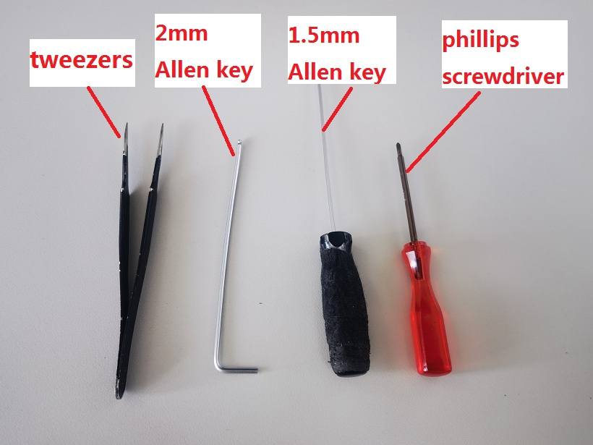

Backlash adjustment method of DEC worm wheel and worm gear
1) Tighten the DEC black clutch knob, and remove the six stainless steel screws from the DEC cover by a 1.5mm Allen key, as shown below.
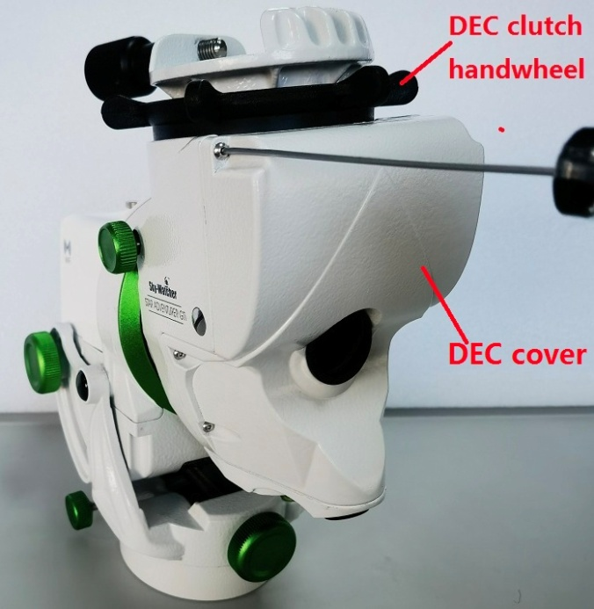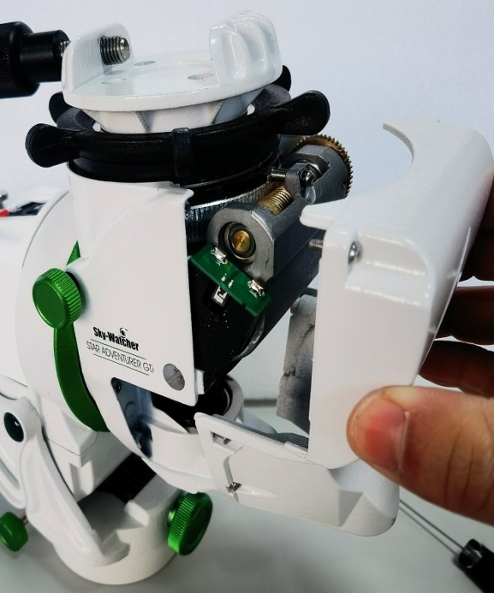

2) Use a 1.5mm Allen key to rotate the stainless steel screw of worm wheel base clockwise (to reduce the backlash) or counter-clockwise (to increase the backlash) to adjust the backlash, each rotation angle is around 30 degree. Then feel the backlash by turning the saddle by hand until no obvious backlash is felt. At the same time, please note that the elastic washer cannot be pressed completely flattened. Please ensure this washer leave a little elastic distance.
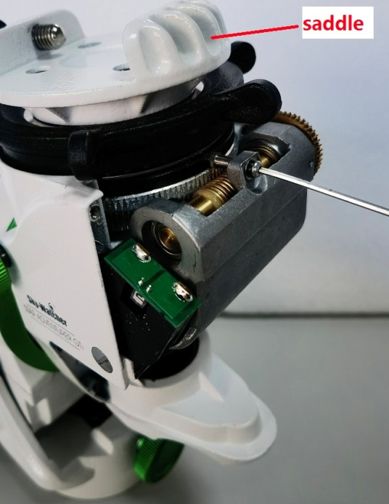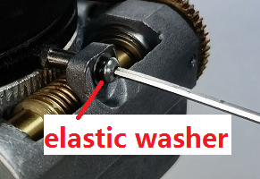

3) Assemble the DEC cover, and tighten the screw with a smaller torsion (Don't use too much torsion). Please make sure the DEC cover fits metal base without light leakage.
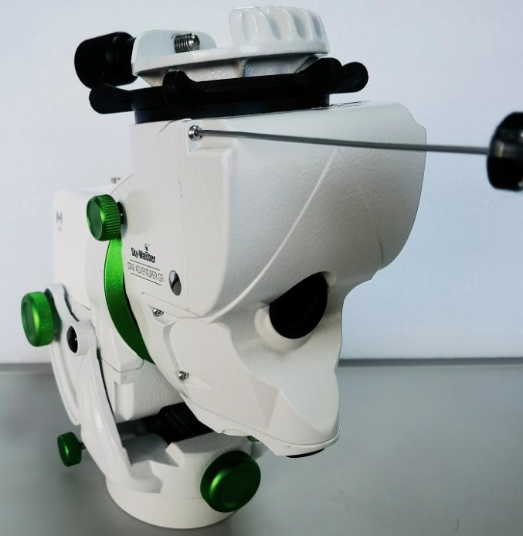

Backlash adjustment method of RA worm wheel and worm gear
1) Tighten the RA clutch knob, and adjust the RA to the latitude 50 degree above. Then peel the black sticker off with a utility knife or a very thin piece of metal, as shown below.
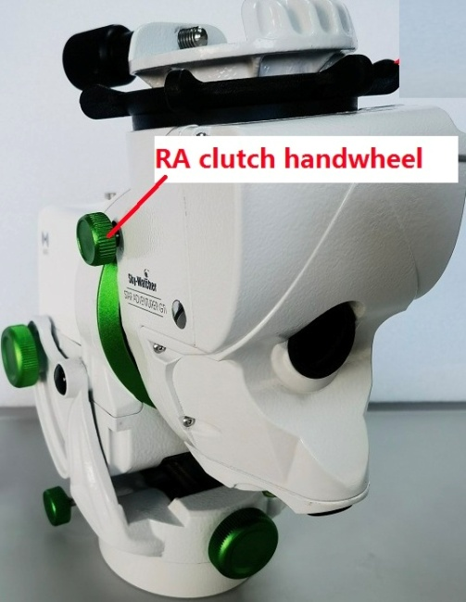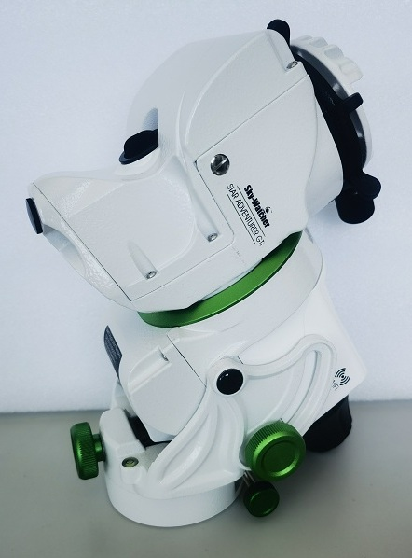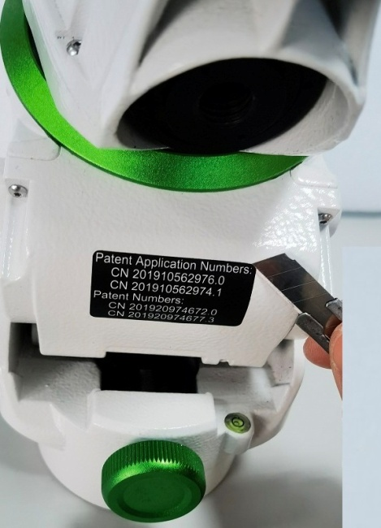

2) Use a 2mm Allen key to align the center of the hole, adjust the hex screw, and turn it clockwise (to reduce the backlash) or counter-clockwise (to increase the backlash) as shown below.
Note: Slowly turn the Allen key clockwise (say about 20° at a time) while gently turning the DEC assembly back and forth by hand until no backlash is felt. Finally, put the black sticker on again.
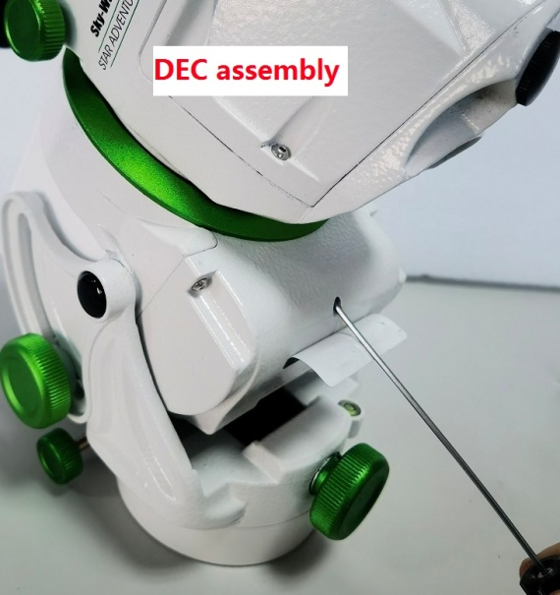

Motherboard of Replacement
1) Remove the green latitude locking knob on both sides of the mout, adjust the latitude to the appropriate position, remove the black screw by turning it counterclockwise with a 2mm Allen key, and then remove the pull rod, as shown below.
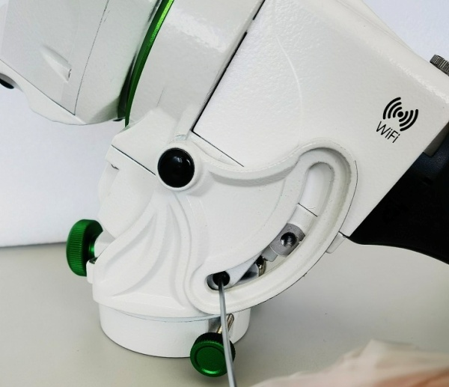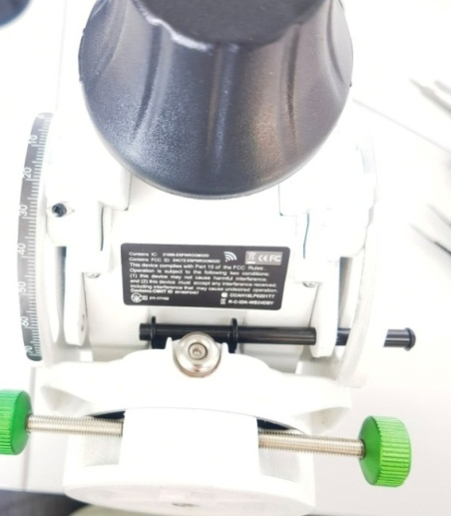
2) Carefully remove the black plastic label on the right side with a tweezers and utility knife, and turn the locking nut of the rotating shaft counterclockwise out, as shown below.
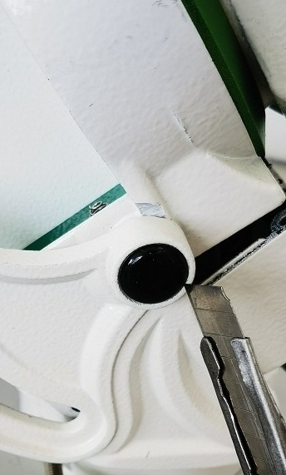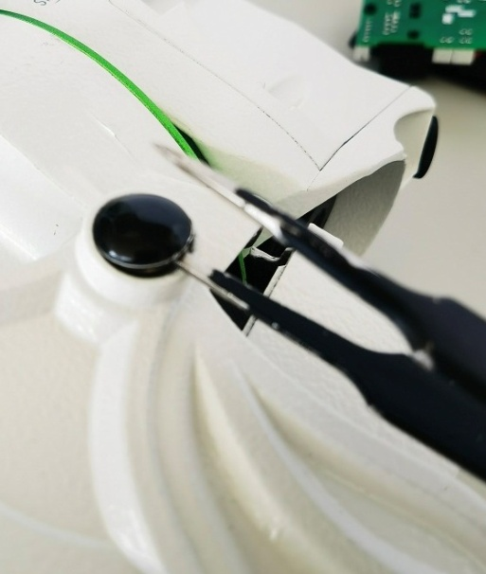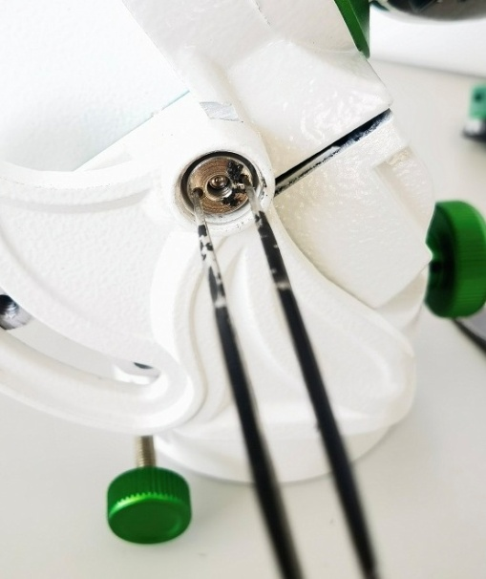

3) Remove the RA assembly by pushing out the shaft bolt slightly with a screwdriver, as shown below.
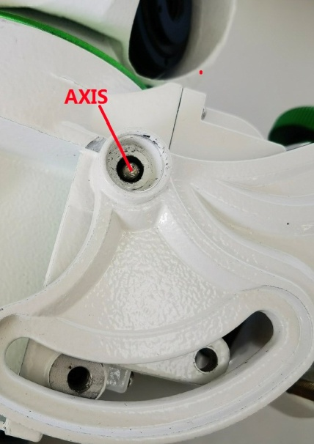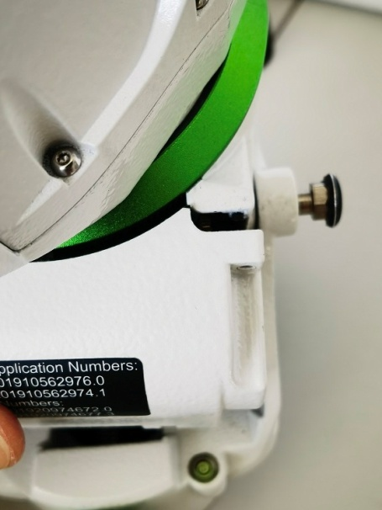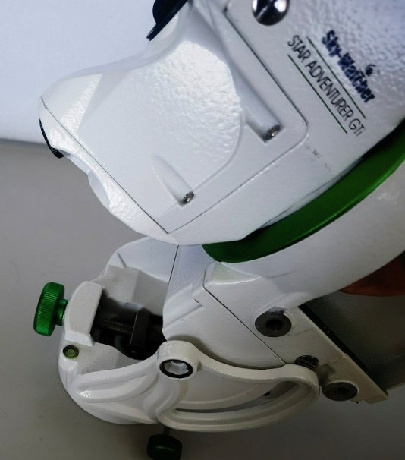

4) Remove the four stainless steel screws from the RA cover with a 1.5mm Allen key, as shown below.
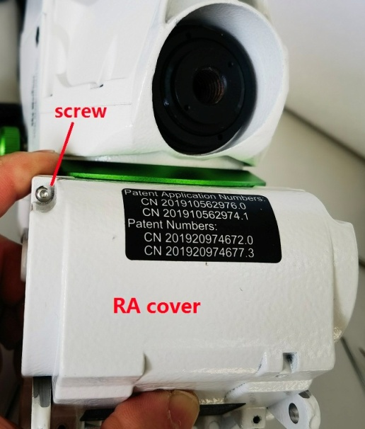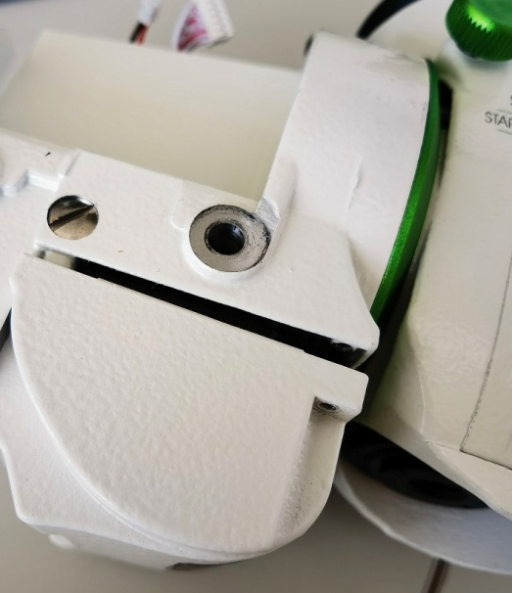

5) Use a screwdriver to remove the five cross countersink screws from the interface cover. Please keep in mind of the installation positions of all connection cables, and remove all the marked connection cables from the interface board IF005, as shown in the following figure.
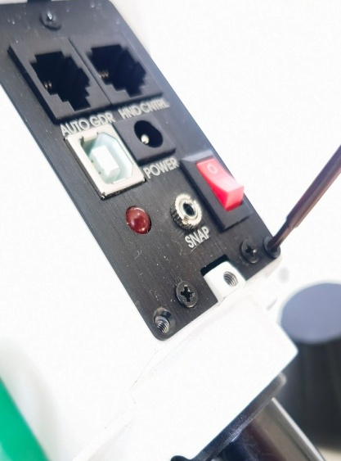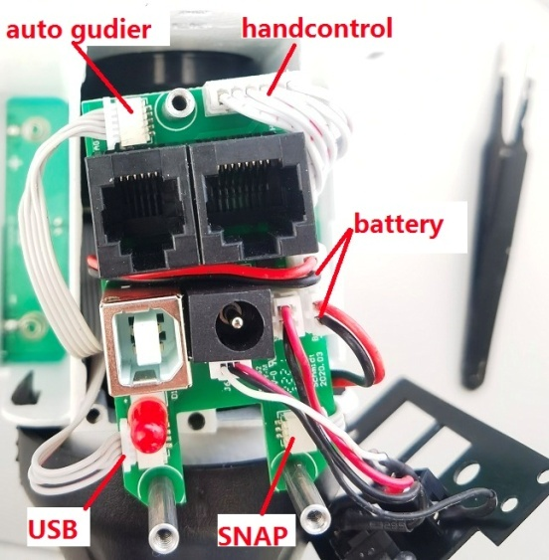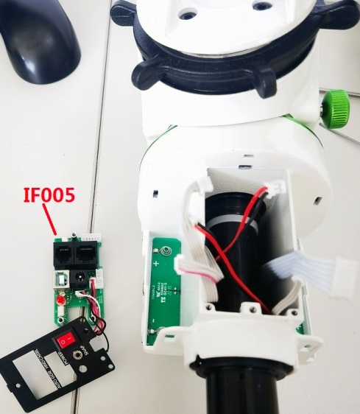

6) Remove the RA cover and use a screwdriver to remove the two cross screws from the motherboard. Carefully remove the reinforced hot melt glue from the connector and pull out the connector. Replace the motherboard with a new one and install the board with screws again.
Note: The switches on the new motherboard should be correctly set as shown in the figure, and the arrangement, distribution and fixing of all connection cables should also refer to the figure. All connecting cables must be reliably connected and securely installed. Use hot melt adhesive to reinforce the connection cables at the joint of the white connector on the motherboard, as shown in the figure below.
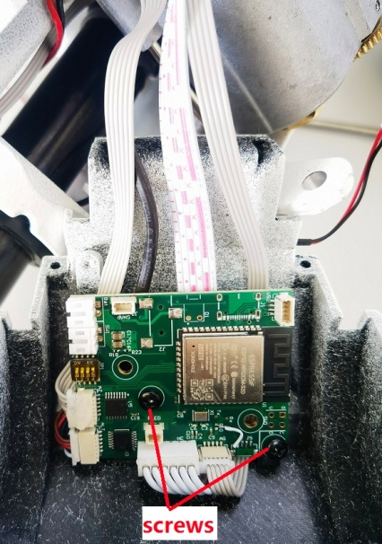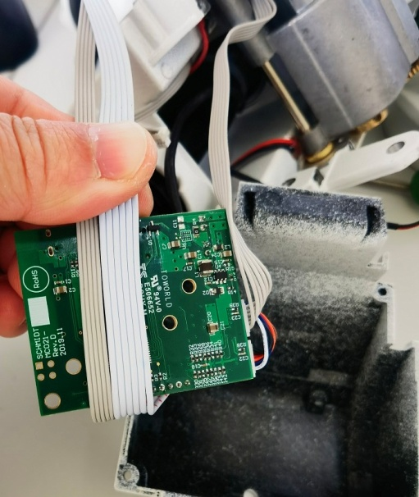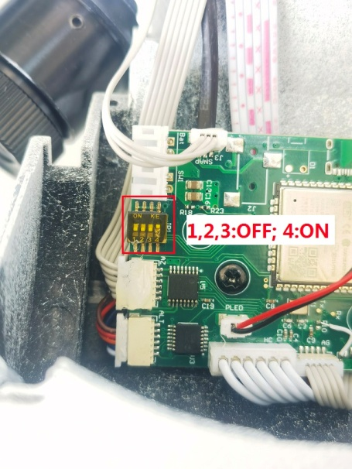
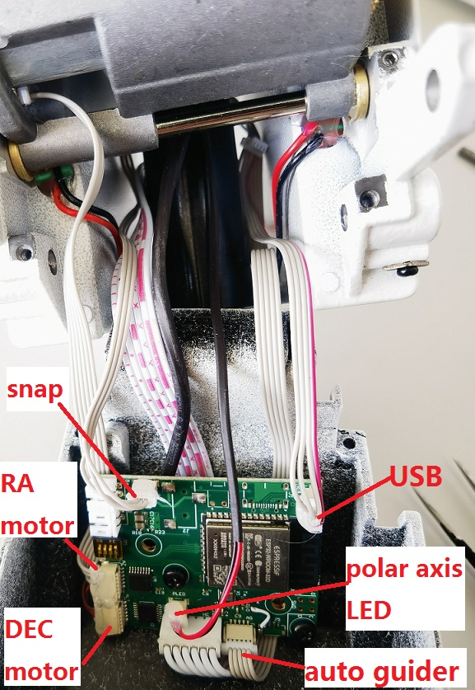

7) After replacing the motherboard, install the RA cover on the RA assembly, and lock the RA cover with four stainless steel screws by a 1.5mm Allen key.
Note: Tighten the screws with a small torque force (do not use too much force), and ensure that the edge of RA cover fits into the metal seat without light leakage. When installing the RA cover, ensure that the internal cables are not pressed by the edge of the RA cover.
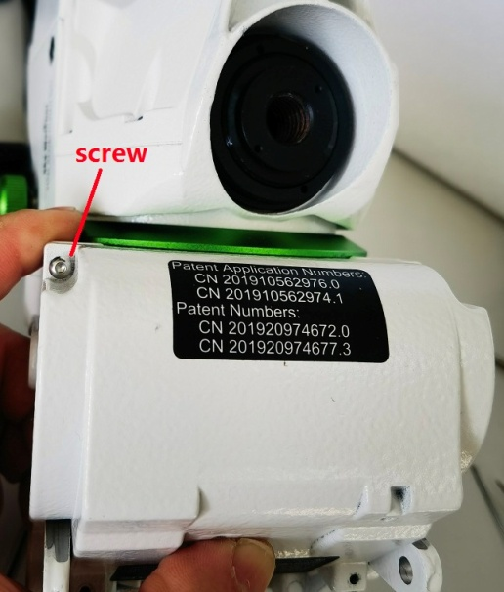

8) After the RA cover is installed, arrange the cables and insert the cables into the interface board IF005 correctly, and lock the interface cover and interface board with a screwdriver.
Note: All the cables should be inserted into the correct position reliably, as shown in the following figure.
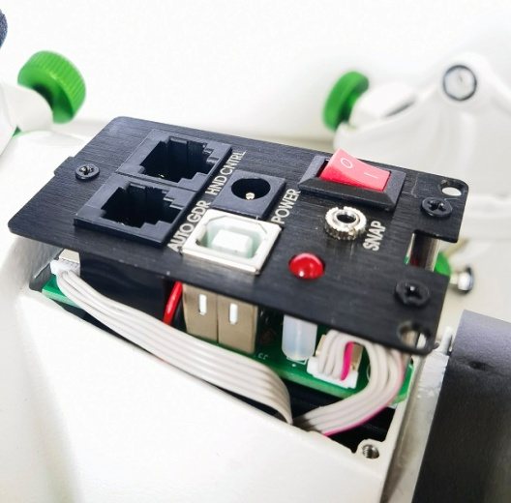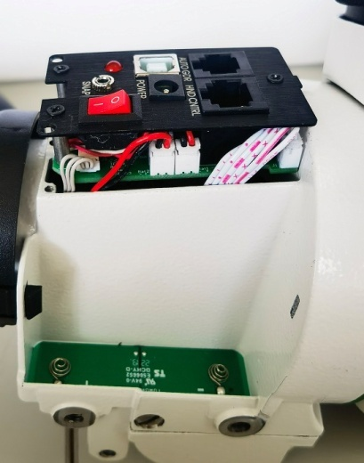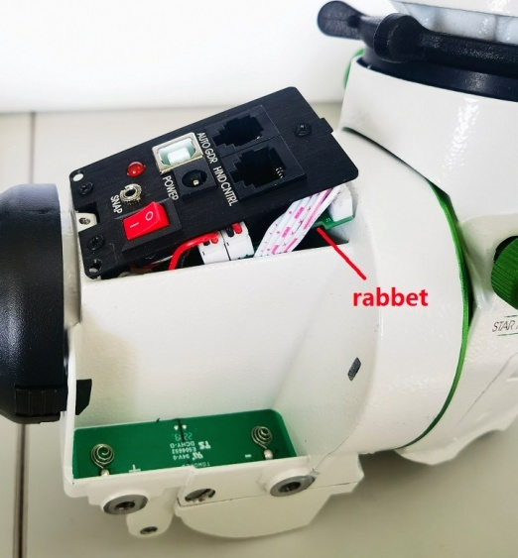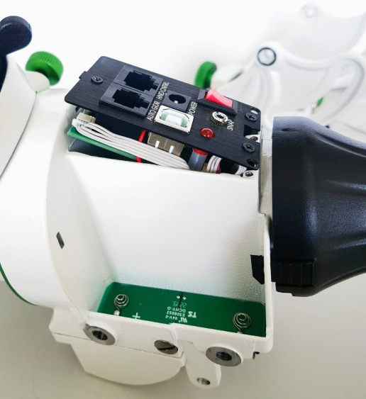

9) Connect the external power supply (or use the battery compartment) to power the mount, and use the mobile phone APP or controller to control the mount to rotate at a fast and slow speed, and check whether the motor has abnormal sound, as shown in the figure below. If the motor works normally, then continue to assemble.
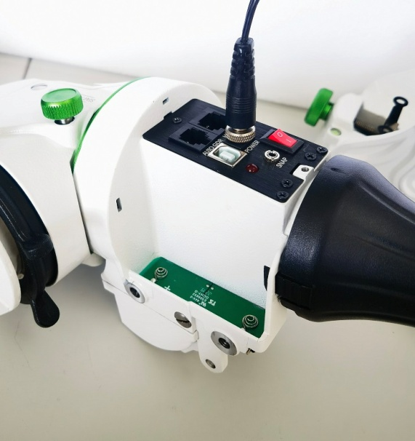

10) Install the RA assembly on the support mechanism, insert the shaft bolt into the shaft hole, apply a little Loctite 242 thread glue on the thread of the shaft lock nut, and tighten it with tweezers, as shown below.

11) Glue the black plastic label onto the rotating shaft locking nut, as shown below.
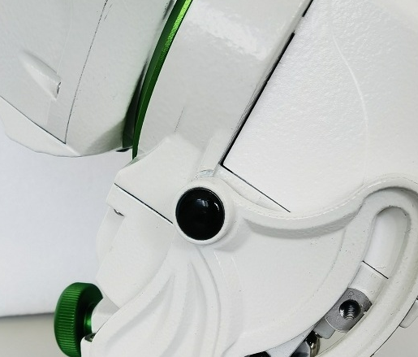

12) Thread the pull rod through the hole in the RA assembly and black pull plate, and fasten the screw to the pull rod using a 2mm Allen key, as shown below.
